FIVE STOLEN BOATS, ONE BROKEN HEART
Posted on April 8, 2019 by Jenn Thornhill Verma

Five model boats were stolen in Ottawa during a hectic move, leaving one Newfoundland man heartbroken. The man is my second cousin, Frank Thornhill. Thornhill, 65-years-old, was in the midst of preparing for his move from Ottawa, Ontario to Grand Bank, Newfoundland and Labrador (NL), when the boats were nabbed, right from his home. Thornhill was living on Baseline Road near Merivale Road in central Ottawa at the time the boat-napping happened – on or around October 3, 2018. He reported the stolen property to police, but the crime wasn’t a high priority. Months later, there remain no leads. That’s why we’re trying to get the word out now.
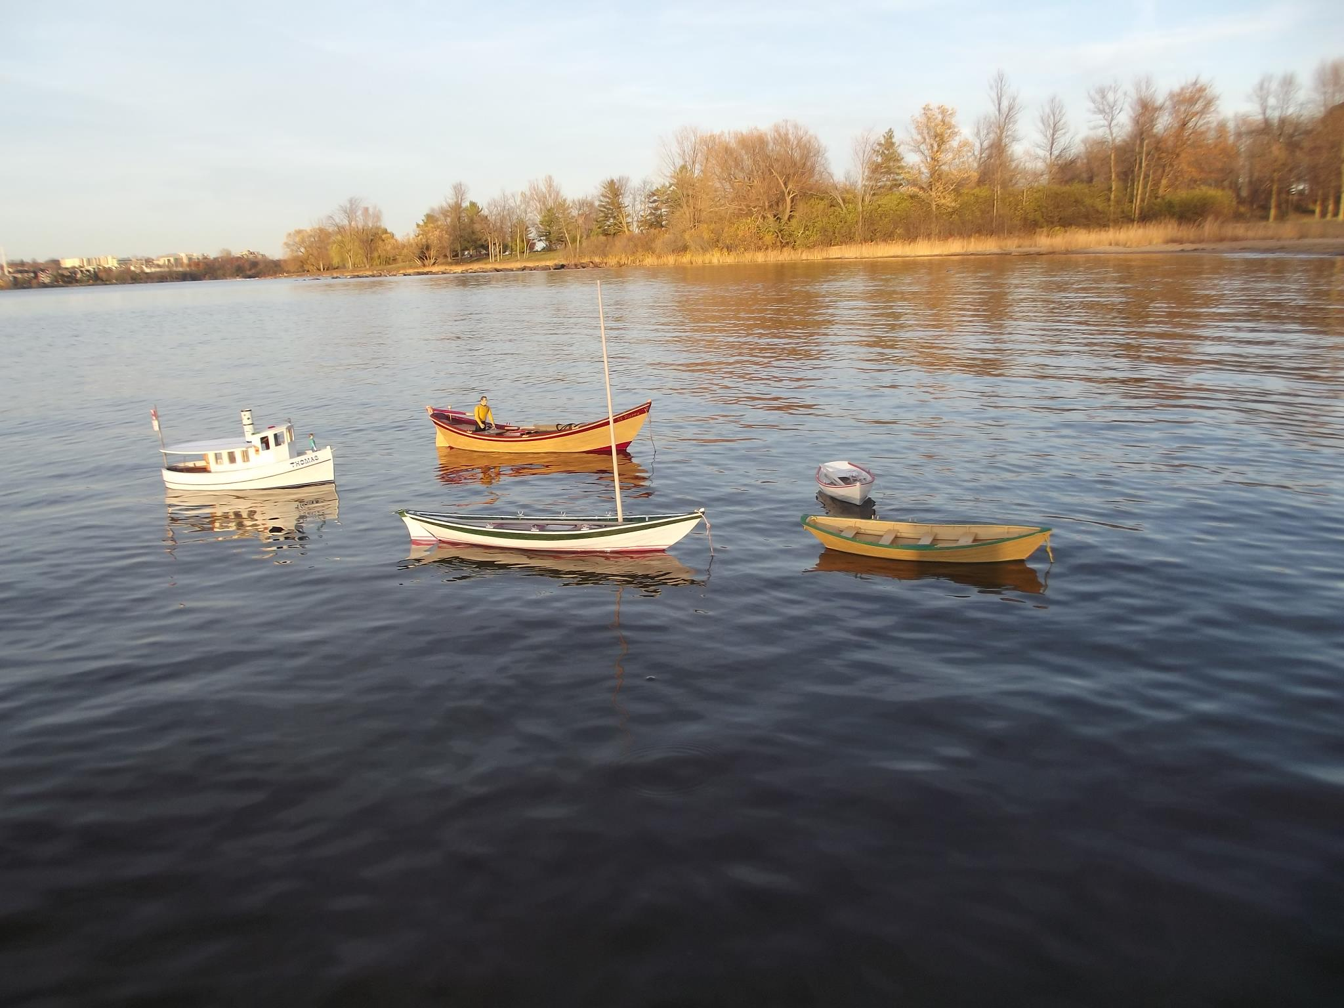Have you seen these boats? Model boats by Frank Thornhill stolen October 2018 from central Ottawa. In this photo, the models are mooring on the Ottawa River: Tour boat (left), St. Pierre Dory (middle back), Beachcomber-Alpha Dory (middle front), Swampscott Dory (right back) and Bank Dory (right front)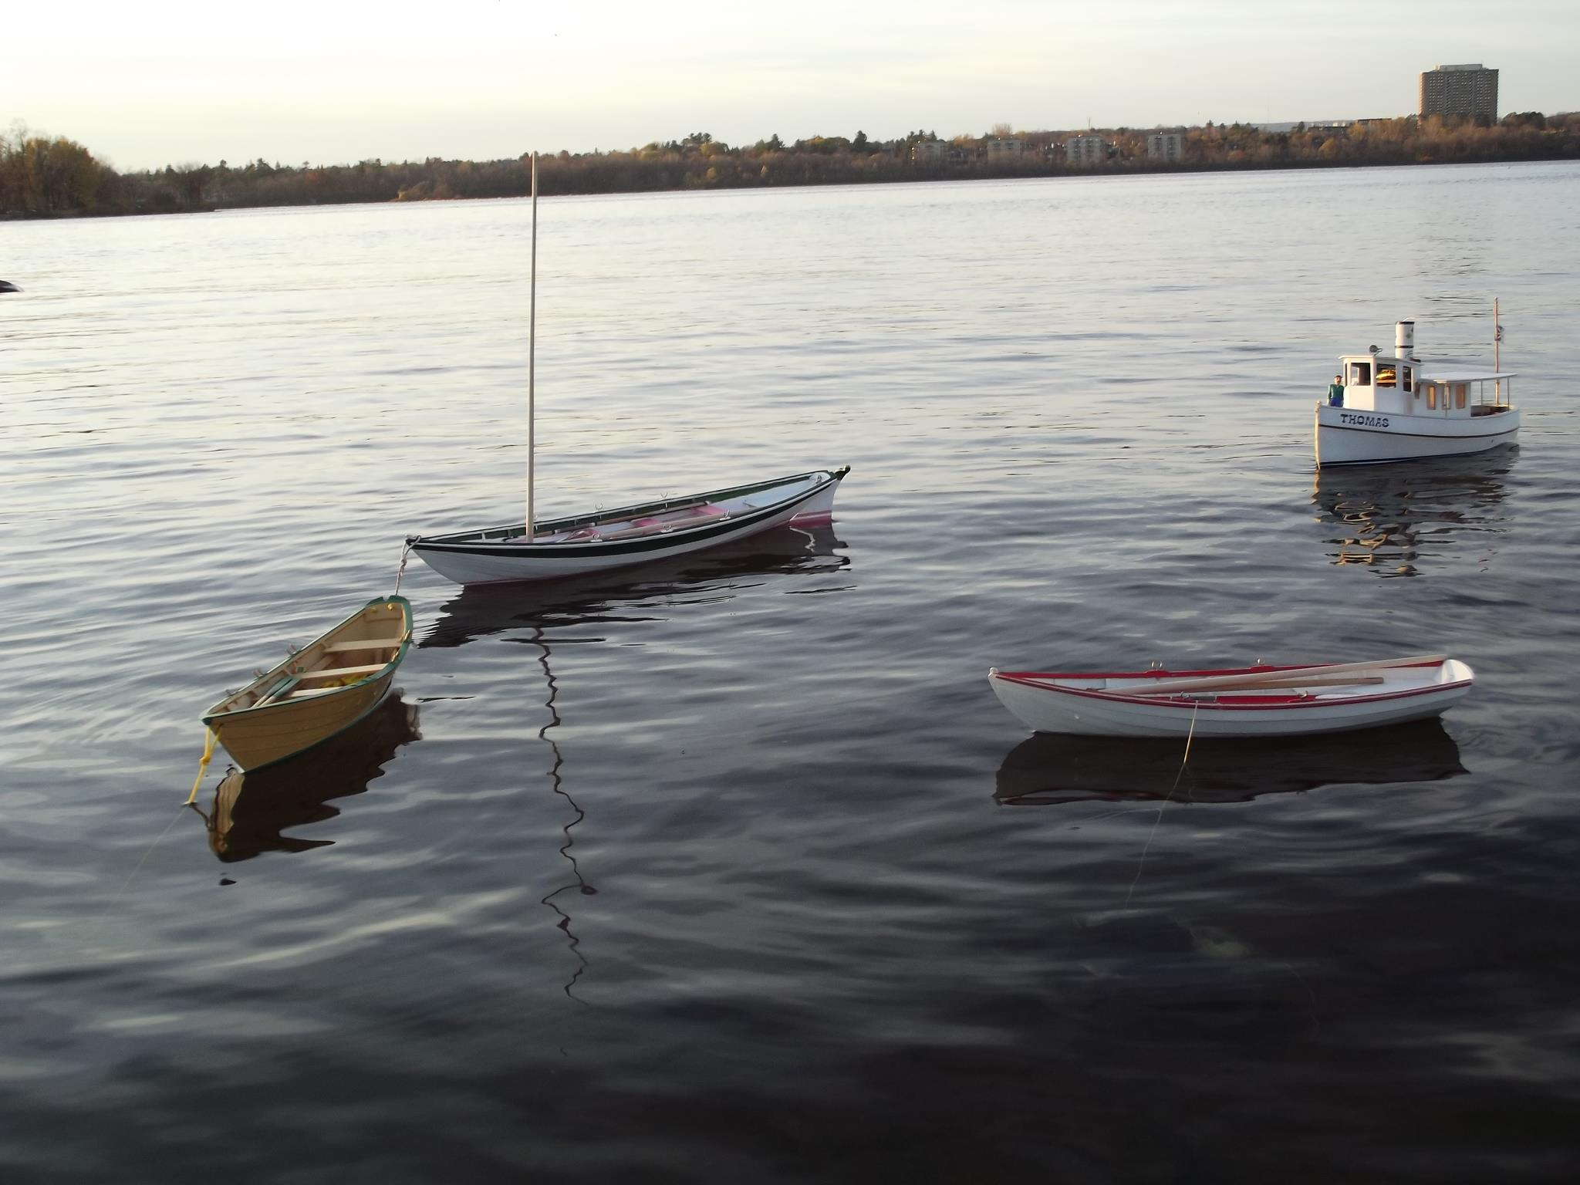Have you seen these boats? Model boats by Frank Thornhill stolen October 2018 from central Ottawa. In this photo, the models are mooring on the Ottawa River: St. Pierre Dory (left), Beachcomber-Alpha Dory (middle back), Swampscott Dory (middle front), Tour boat (right)

For Thornhill, it’s not the cost of the boats that matter, it’s the sentimental value. The boats are a link to the past, Thornhill says. He, like many Newfoundlanders and Labradorians, remembers his father, uncles and others launching their dories from the shores of Little Bay East, on the southeastern coast of the province, on the Burin Peninsula. Thornhill returned to live in that area last fall. He has divided his life between Ontario and NL. He spent the better part of the last 45 years in Ottawa, but it’s NL – and the Burin Peninsula in particular – where he bookends his life. The island portion of the province is where Frank Thornhill was born and raised (Little Bay East) and where he has recently returned to live once again.
Last August, Thornhill donated a model dory for a fundraiser for the Grand Bank Community Youth Network. It was a gesture to give back to a community he grew up in and was returning to live. The story was picked up in the Southern Gazette.

Thornhill, who has a background in carpentry and cabinet-making, thinks about what he left behind in Ottawa. Photos of his model boats show Thornhill’s attention to every detail—each one is crafted by hand, mostly from wood, and painted using artist-quality acrylic paints. They were waterproofed, so could be used on the water. Two of the models were remote-control operated. All of the models were completed in 2007 or earlier, comprising a mini-collection—one that Thornhill had hoped to pass onto his only son, Thomas, who is the namesake of one of the model boats.
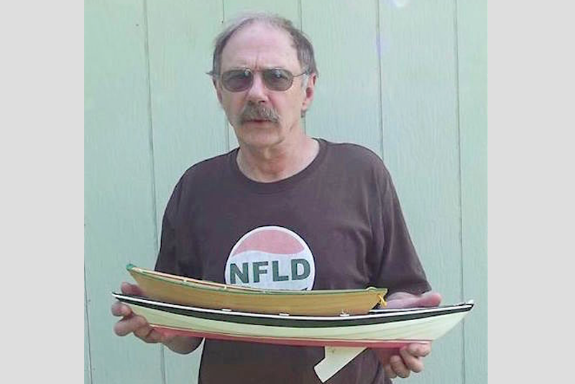Frank Thornhill, now 65-years-old, holding two of the model boats stolen in Ottawa last October.

ABOUT THE MODEL BOATS
The following five boats were stolen last October with their accessories (wooden paddles). More photos are available. The owner, Frank Thornhill, asks anyone with leads to please leave a message here (comment below or send an email via the contact page).

Bank (or Banks) Dory– model of a 12-foot bank dory, painted yellow and green. Named after the Grand Banks fishery for its role as a traditional fishing boat, the dory’s yellow colour is said to have showed well against dark waters, while its green trim showed in fog. These dories were typically longer than Thornhill’s model (e.g., they could be 16- to 23-feet long). They were considered a ship’s boat, stacked on board a Banks schooner to be launched from the main vessel, or mothership, to fish. They influenced the local fishery and are still visible across NL, often painted in the yellow-green motif.

Beachcomber-Alpha Dory– model of a 21-foot beachcomber dory, painted in tribute to the unofficial Newfoundland tricolour flag (pink, white, green). “Its adventure comprises one episode in American boating history that deserves repeating,” writes Thornhill, “From about 1900 to 1910 these superb sailing dories were in their heyday. Designed and built by William H. Chamberlain in Marblehead for the Beachcomber Club of that town, where the dory got its name, the same boat, with a slight difference in its rig, was adopted by the Alpha Dory Club of Salem about 1906 or before where it known as the Alpha Dory. The challenging thing about building the Beachcomber is that it has about 96 different measurements in doing its layout, as its boards change, especially at the rear frames where each board rises a bit differently than the next one above it. In a small bank dory there may be about 14 different measurements, so it’s a bit of a different creature to build. It was to be eventually rigged to sail.”

Tour Boat (“Thomas”)– built from a model kit from Midwest Products with customized details and painted in a Canadian (red, white) theme. Most notably, it featured a working, wood-carved door to the cabin with a glass bead for its handle. The cabin had Winnie the Pooh details and the boat was named, Thomas, after Thornhill’s son. The cabin’s interior was partially finished, and the model was remote-control operated.

St. Pierre Dory– built according to the offsets of a 27-foot dory, painted mustard yellow and magenta/red. Thornhill relied on John Gardner’sThe Dory Bookfor its offset charts. It was remote-control operated, with a pull-up propeller, just like the real thing, could be pulled up when beaching the dory. This model has Frank Junior Thornhill’s initials (FJT) and St. Pierre inscribed on a brass plate, where the steering rod comes through for the rudder arm. This dory is named after St. Pierre et Miquelon, the French archipelago off the southeastern shores of NL.
Swampscott Dory– built according to a 12-foot Swampscott dory, painted in a Canadian (red and white) theme. They were named after the town of Swampscott in Massachusetts and intended to be launched from the beach. This style of dory preceded the Banks dory.

