BOOK REVIEW: ALAN DOYLE’S WHERE I BELONG (2014) & A NEWFOUNDLANDER IN CANADA (2017)
Posted on November 9, 2017 by Jenn Thornhill Verma

How would you like to take a cross-Canada tour on a band van with running commentary from a prominent Newfoundlander? I promise it will be a laugh-out-loud journey not to mention an entirely unique way to discover (or rediscover) this country.
Last month I had the chance to meet musician, actor and author Alan Doyle at The Ottawa International Writers Festival. I had already read his first book, a national bestseller, Where I Belong: Small Town to Great Big Sea and was ready to hear more about his latest and just released book called, A Newfoundlander in Canada: Always Going Somewhere, Always Coming Home. As a Newfoundlander living in Ottawa working on my own creative nonfiction book, I found so much of what he talked about and writes about relatable. The thing is, I could be neither of those things and would still find it relatable because that’s precisely what Doyle does best – he translates his experience in a way any reader can appreciate and take meaning. Whether you know Alan Doyle, the Newfoundland Celtic-rock band Great Big Sea, Newfoundland or Canada almost doesn’t matter, but expect to learn a lot about each of them and more along the way.

Where I Belong
Doyle’s 2014 bestselling memoir is a coming-of-age story about his life as a Newfoundland boy turned celebrity frontman of the band Great Big Sea. I have a couple of takeaways from this book.

First, Doyle does a brilliant job relaying what it means to be a Newfoundlander. In an attempt to relate culture and experiences, it can be tempting to rely on old clichés and typecast characters. Doyle avoids this (no “Newfie” jokes here), presenting narratives that show versus tell. For example, to relay that Newfoundlanders are hard-working he writes, “That’s the way it was in rural Newfoundland. You didn’t call professionals to build you a house or put a roof on it. You called the boys, and you got a few cases of beer and you did it yourselves” (p.12). Or to convey the rough around the edges demeanor of outport Newfoundlanders he starts with a description of the design preference of clapboard-clad homes to showcase the rough (versus smooth) side of the lumber: “Come to think of it, that’s the way most Newfoundland houses and Newfoundlanders themselves are built: rough side out” (p.13). Doyle doesn’t shy away from more familiar proof points, referencing kitchen parties and Come From Aways (anyone not from the province), but he does so relying on description and story.

Early on in the book, Doyle shares he’s a first-generation Canadian given his parents were born in pre-confederation Newfoundland. He writes about the cod moratorium and demise of the inshore fishery at that time and how it impacted Canadians’ perceptions of Newfoundlanders (p.82-84). Newfoundland came to be known as a “have not” province filled with unemployed, uneducated lazy sponges. Doyle takes care to show the true stories of the people on which this former dominion and Canadian province was built.

The primary narrative of the book focuses on Doyle’s life pre- and post-celebrity in Petty Harbour. He drops celebrity connections and references throughout but in a completely off-the-cuff, sidebar way (zero pomposity here; the man is truly genuine). This brings me to my second reflection. To make his book all that more personal, Doyle adds family photos, recipes (e.g., his mother’s bread, p.52) and tips (e.g., how to cut cod tongues, p.86). As a reader, I enjoyed this access to insider information, which is appropriate for memoir style, like reading a diary entry or personal letter.

All told, Doyle’s first book shows he’s a true ambassador for truth-telling and confronting myth and stereotype about Newfoundland and its people. It’s a theme he picks up in his next book.

A Newfoundlander in Canada
In the way that Doyle’s first book is revealing of Newfoundland, his second book is revealing of Canada. Granted that statement needs qualification. We learn about the ten Canadian provinces, but we don’t learn about Canada’s northern territories, from east to west, Nunavut, Northwest Territories and Yukon Territory. The reality of a band touring cross-country by van is enough rationale to explain why this is the case. Doyle discusses the sheer scale and size of the country throughout his book. If we add to that getting to and fro the territories, we’re in another realm scale- and size-wise. Still, Doyle’s ability to offer revealing detail about ten provinces in 240 pages is a worthy feat in and of itself.
To help relay his province-by-province impressions, Doyle talks about each province as if they are a family relative of his native Newfoundland (summarized in the Table). Each chapter goes into far more extensive detail, but these summary statements offer a flavour for Doyle’s light-hearted and personable style of writing. Take, for example, the lengthy comparison between the capital cities of Prince Edward Island and Newfoundland and Labrador. Doyle shares a typical response to a tourist asking for driving directions from the scenic downtown to the nearby university campuses in both Charlottetown and St. John’s. The Charlottetown response is two sentences long; it’s short, sweet and to the point. The St. John’s response goes on for 1.5 pages and is filled with extraneous information, roundabouts and cautious advice about how best to avoid turns that take you right back to where you started (p. 61-3). The narrative shows the differences in terrain, but fundamentally is about the differences between the people. It’s brilliant.

TABLE. EXCERPTS FROM ALAN DOYLE’S 2017 A NEWFOUNDLANDER IN CANADA RELAYING EACH OF THE TEN CANADIAN PROVINCES AS A FAMILY RELATIVE TO NEWFOUNDLAND
Canadian Province | Description in relation to Newfoundland
Nova Scotia | p.34 “Nova Scotia is like a cousin to Newfoundland. Not a cousin who lives down the road, but one who lives in another province who you see every other summer. You are expected to know a lot about each other, but you really don’t until you meet in university and spend some actual time together.  During the writers festival in Ottawa an audience member asked Doyle about how he’d summarize Cape Breton. He said: “Cape Breton would be the cousin you sneak away from the supper table with to get two beer.”
Prince Edward Island | p.66 “P.E.I., I figured is Newfoundland’s sensible sister. Definitely from the same family, but nowhere near as wild. And she’s more organized and way prettier, especially when she does herself up for visitors.”
New Brunswick | p.95 “New Brunswick, I supposed, is Newfoundland’s quiet cousin. She gets very little air-time at the supper table, but is way more complex and fascinating than you might have thought.”
Quebec | p.116 “Quebec and Newfoundland and Labrador might be seen as step-brothers, at best reluctant family members brought together by a marriage neither wanted very much in the first place.”
Ontario | p.126 “Ontario is Newfoundland’s most popular and successful sibling. The country’s favourite kid. The star of the family who the others are sometimes jealous of but are really quite proud of and secretly love.”
Manitoba | p.180 “. . . so much about Manitoba was beyond any description I’ve ever heard. She’s the sister you think you know everything about, but you really, really, really don’t.”  In his book, Doyle expands on this idea, writing about Manitoba’s appreciation for the arts. For example, he points to the countless Manitoba-born musical acts that have sold upwards of half a million records.
Saskatchewan | p.194-5 “Saskatchewan is the fraternal twin to Newfoundland. Separated at birth. They look nothing alike, but once you get to know them both, it is impossible not to see how many personality traits they have in common.”
Alberta | p.210 “Alberta is Newfoundland’s big brother. The one your parents had way before you and who had moved out before you were even born. It is almost a given that you’ll go to his place for a while when you get out of school and are just getting started as an adult.”
British Columbia | p.228 “British Columbia is the very distant cousin that lives far far away and Newfoundland sometimes finds confusing. He goes into the ocean recreationally, and is in way better shape than you ever thought possible.”

During the Ottawa writers festival, CBC’s Alan Neal talked to Doyle about everything from his thoughts on the term “Newfie” to being a recently minted author. It was a fabulous interview and I want to share a couple of points that particularly struck me. While I use quotes herein, these are from my hand-written notes, so it’s best to consider these as paraphrased responses.
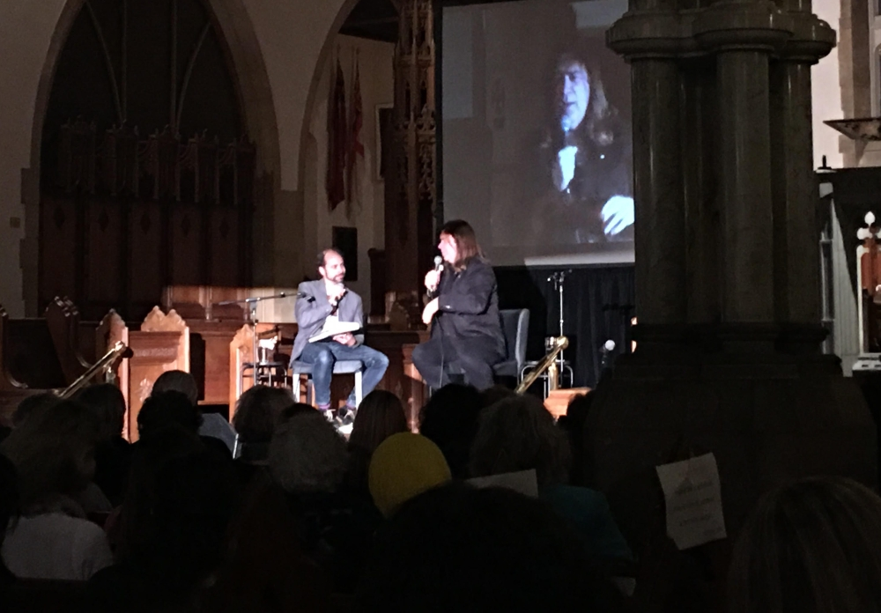CBC’s Alan Neal interviews Alan Doyle at The Ottawa International Writers Festival

On the term Newfie Doyle said, “You can tell if there’s love in it [when people use the term]. I wish Newfie was a cute abbreviation for Newfoundlander…” but Doyle reminds us the term was made up during the Second World War to insult Newfoundlanders. He also talked about Newfie jokes (definitely paraphrasing here) “I was confused about Newfie jokes because they always seemed to be about lazy people, but the people in Petty Harbour woke up at 2am to go fish and returned at 2pm and then they’d go chop wood and build a house.” He goes on to say, “I don’t know anyone offended by [the term] Newfoundlander.”

Doyle also talked about the writing process: “The hardest part about writing a book is writing a book.” He says people think they just need that one idea or that first page but acknowledges there’s “a mountain of stuff you have to do.” After having written his first book he had a good gag going when people asked about his writing process. “When you’ve written as many book as I have…” but with his first book now a bestseller and launching a second book (destined for the same bestselling status), Doyle no longer jokes about having insights to share. With his first drafts, he’s not trying to be “awesome,” he’s trying to get the words down on the page. He then takes time to review and edit section by section. Doyle even records himself saying the words on the page – “If it doesn’t sound like me, it’s not going in the book,” he says.

The man is a class act. He even ended the festival evening with a song, then stuck around into the wee hours of the eve to early morning to meet the audience and sign books (Nevermind the fact that Doyle had to drive to Montreal for a breakfast television appearance the next day).

At one point throughout the evening, Doyle talked about his appreciation to Newfoundlanders – they were as responsible for introducing Great Big Sea to Canada as he and his bandmates were for introducing Newfoundland to the country. Those are not just words. The man is grateful. It’s like his father once told him, “For every pat on the back there’s ten boots to the arse.” True to his roots, Doyle works hard, is deeply appreciative, doesn’t take his success for granted and is every bit a proud Canadian from Newfoundland as he is a proud Newfoundlander in Canada. I recommend these books and you may want to listen to his latest album while you’re at it.

